**Improvements Report**

For the methodology of improvement in ontology development, several benchmarks have been addressed.

1. **Hidden relationships discovered & extra knowledge gathered:**

The features in the dataset have been categorised into various classes and groups, forming visible relations with each other. The discovery of hidden relations and their dynamic incorporation to the ontology has been achieved using correlation coefficients between different features. The feature pairs in different classes having high correlation thresholds are gathered and added to the ontology using the property ‘correlatesWith’.

*Hidden correlation relation between properties*

*Logic for deriving unrelated feature pairs having high correlation*

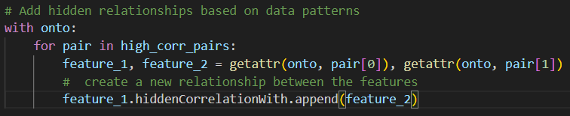

*Adding the highly correlated features to the ontology*

*Example of hidden correlation feature relations*

1. **Better results with the new methodology:**

The results are compared with the papers ([1](https://ieeexplore.ieee.org/stamp/stamp.jsp?arnumber=9888860), [2](https://arxiv.org/pdf/2006.11446) and [3](https://www.scribd.com/document/24058261/Towards-an-Ontology-of-Malware-Classes)), as compiled in the 2nd paper (Chowdhury & Bhowmik), using the aforementioned tool [OntoMetrics](https://ontometrics.informatik.uni-rostock.de/ontologymetrics/).

Our methodology has performed significantly better in almost every aspect, than all the papers.

The base metrics for both the ontologies (with and without addition of hidden features) and the comparison with the above-described ontologies is as follows:

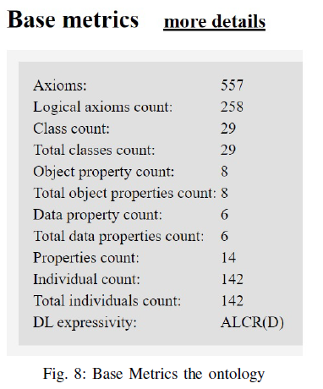

***Chowdhury and Bhowmik***

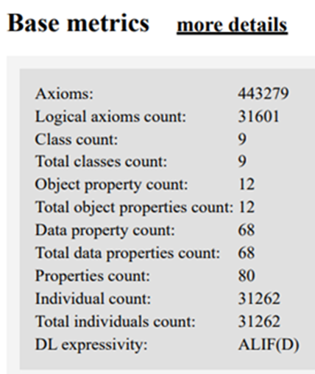***Ontology w/o hidden relations Ontology with hidden relations***

The comprehensive table showing richness of components from all of the mentioned also shows our ontologies surpassing the others in almost every aspect considered by Chowdhury and Bhowmik in their table.

***Evaluation Results***

1. **Verification and validation:**

The verification and validation of the ontology formed was carried out by utilising the [Pellet reasoner](https://github.com/stardog-union/pellet). The successful run verified the consistency and completeness of the individuals, hierarchy, properties and rules defined. Checking for changes in the mentioned components of the ontology, we found none, proving the validity of our constructed ontology successfully.

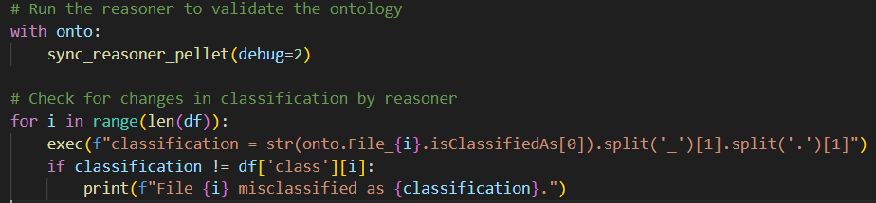

***Code snippet illustrating the Pellet reasoner and post-execution check***

***Output sample after successful run of reasoner (debug enabled)***